**Liber-Primus Hangman demo v0.1**

**Introduction:** This is a working demo, with limited testing. It’s all prototpye code ;-) The purpose of this app is to help find possible phrases that could be in the Liber Primus.

**Requires:** python 2 or 3 and PyQT4 or windows binary LP_Hangman.exe

Tested on linux and Windows 7

**Get ngram data:** can’t share on git too big a file compressed, please see

<https://www.dropbox.com/s/36irgziw9o75b5z/ngram_data.7z?dl=0>

Uncompress ngram_data.7z

**Important:** ngram_data files **must** be in this relative path

<install>\ngram_data\4gram\<letters>\file.text

And

<install>\ngram_data\1gram\<letter>\file.text

**It’s way too big:** The way of separating n-gram data into many files makes access fast, but takes up much more space. This can probably be improved. But don’t we all have many spare GB?

**Run:** LP_Hangman.py

**Known Issues:** The Liber Primus sentences structure is basically correct, but without punctuation at the moment. Sentences with less than 4 words will result in undefined behaviour. Yeah ,we know there’s a lot of data, we’ll keep working on that.

**MORE HELP:** <http://webchat.freenode.net/?channels=cicadasolvers>

**Hints and Tips: Hopefully you should see something like this:**

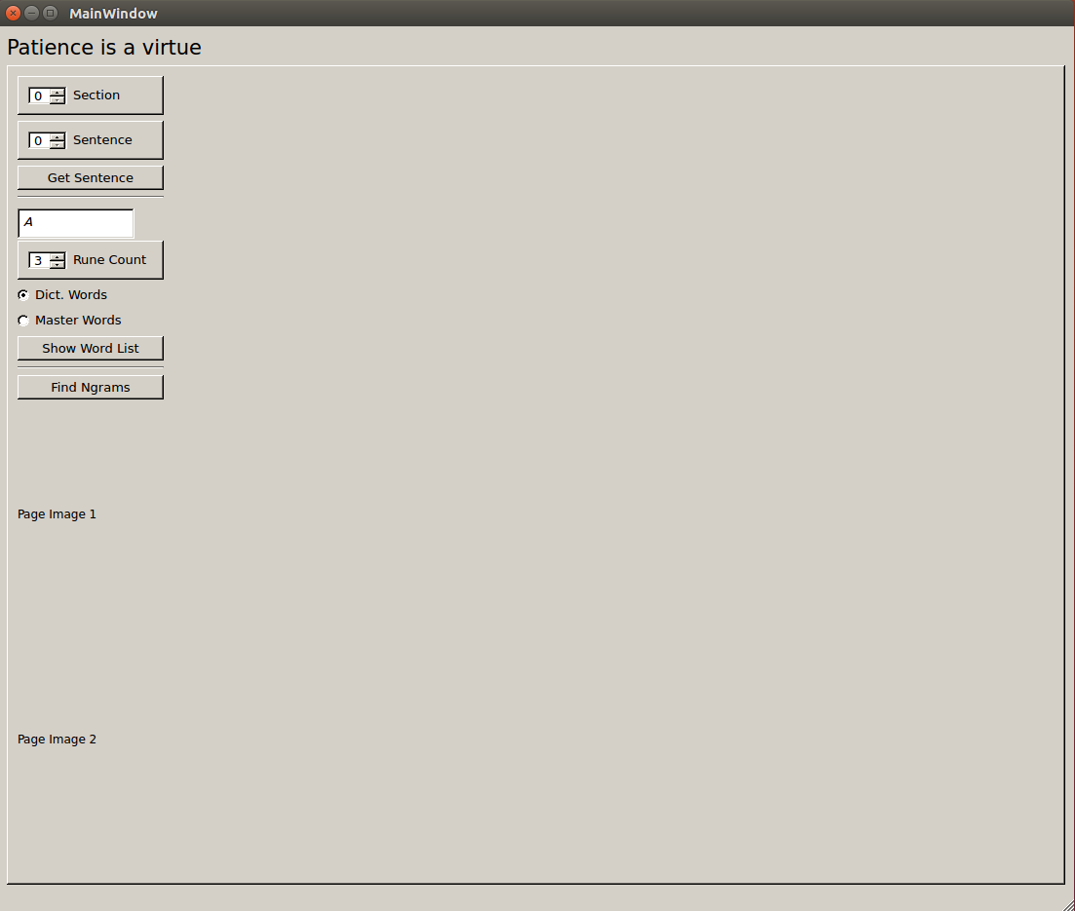

Choose a section (by side images) and sentence (by 4-dots). Press “**Get Sentence**”. This should build the main display with a GUI_wordWidget for each word. The displayed image pages from the Liber Primus are not yet correct.

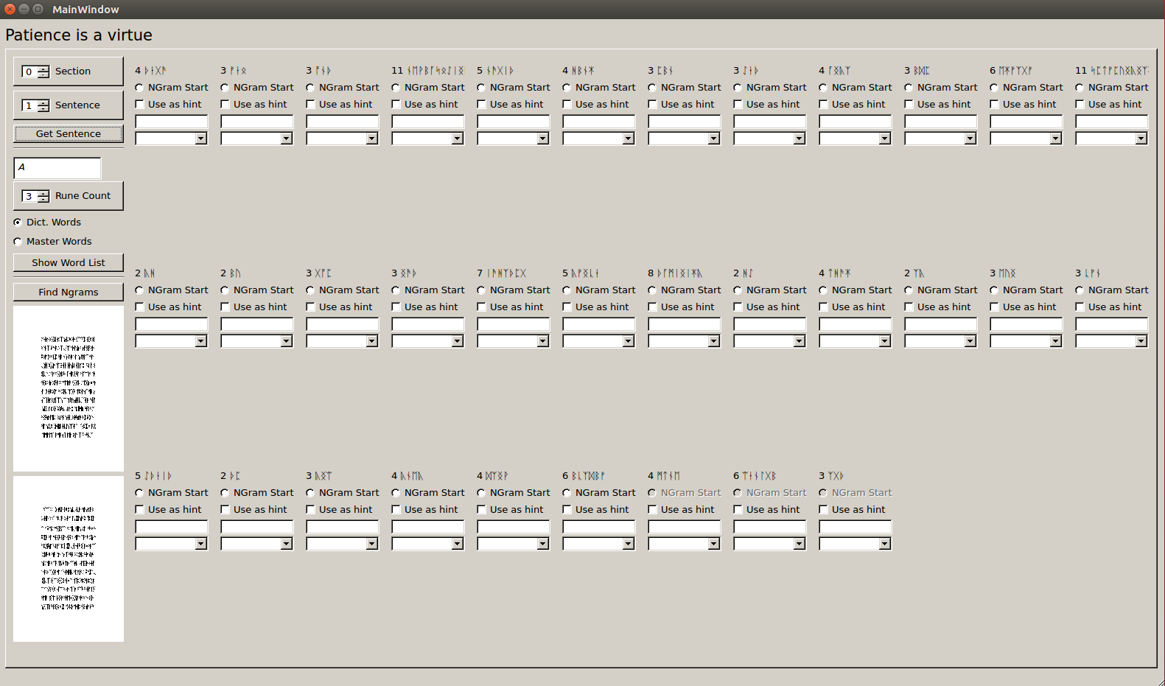

Example GUI_wordWidget

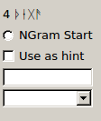

Each GUI_wordWidget has:

***Top label***, with word-rune-count and runes

***Ngram Start*** radio-Button, select to make this word the start of the 4-gram being considered

***Use as hint*** check box, select if you want to use the current Text Entry as a hint when looking up n-grams

***Text Entry***, your chosen word (or first letters of a word)

***Unique Words*,** Combo box that is filled with unique words after an N-gram search

**Choose an N-gram**

We work in 4-grams, choose an Ngram Start radiobutton, this will activate the current and next 3 GUI_wordWidgets and deactivate the rest. The last 3 n-grams of the sentence should always be de-activated.

Press “**Find Ngrams**” this looks up mathching ngrams in the raw data. Each unique word will be added to the combo boxes, and a pop-up-window of all the complete n-grams will be displayed, with counts in the data.

For quicker results choose the first letter (or first few letters) of the first n-gram, and make sure “**Use as hint**” is checked. “**Use as hint**” for each word in the n-gram can be used to narrow your search.

While searching, the search criteria will be displayed in the Top Left.

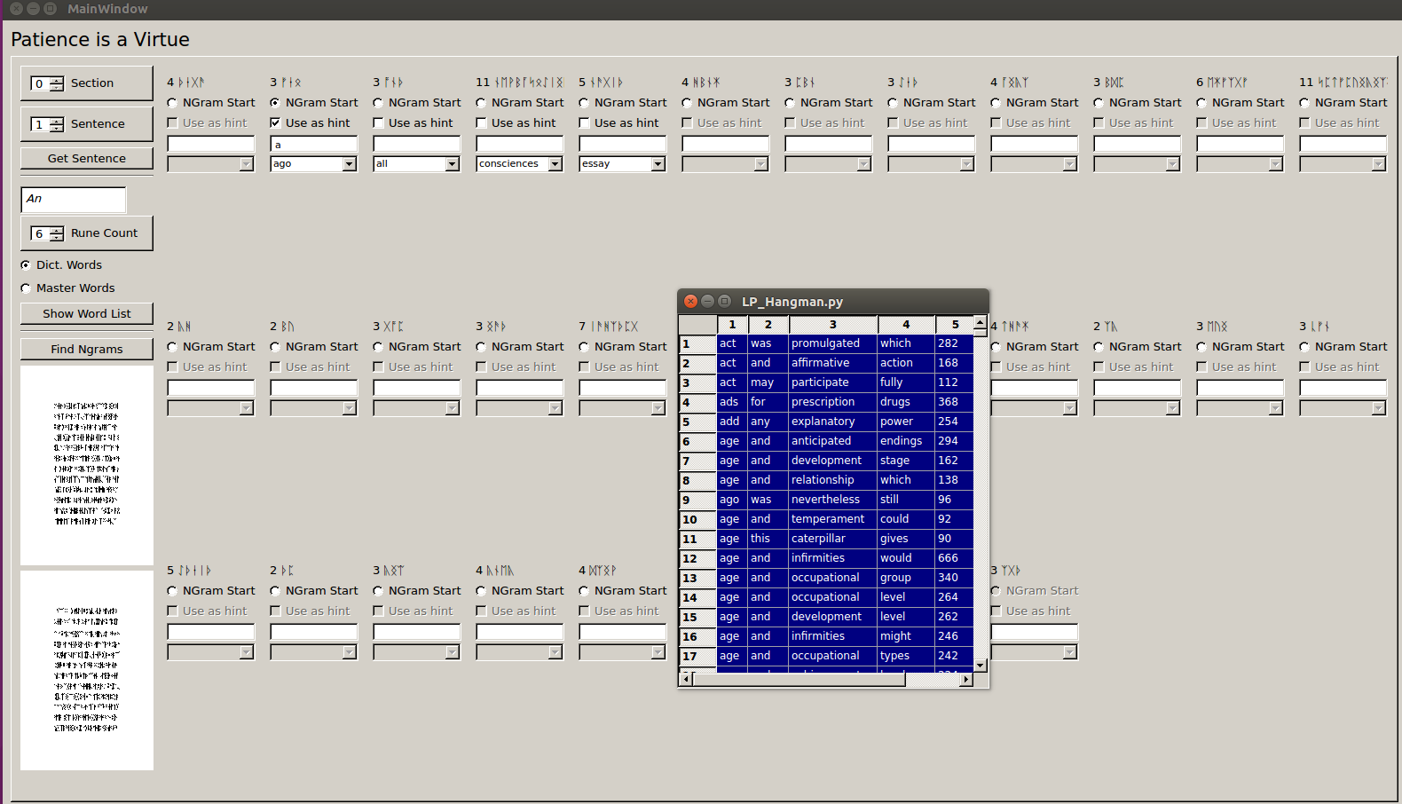

Once you’ve picked a word or two use them as hints and move on to a later ngram.

**oneGram_Finder**

Not sure of what words you can choose? Try the oneGram_Finder, on the Left hand Panel. Choose your starting letters, word-rune-count, and press “*Show Word List*” to display a pop-up window of all matching words, with their count from the corpus.

**Controls**

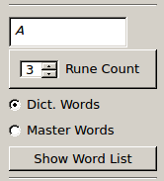

Example 1-grams:

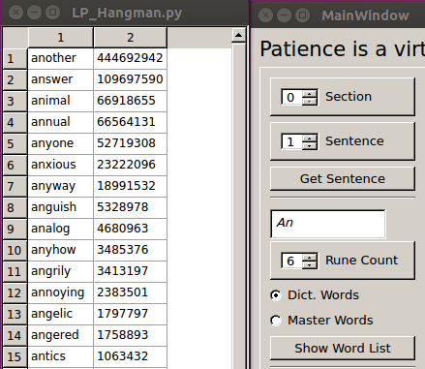

**Master Words** or **Dict. Words ?**

This radiobutton limits the serachs to common words from the master list, or uses all words found In a typical dictionary.